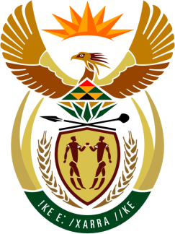

SOUTH AFRICAN PERMANENT MISSION TO THE UNITED NATIONS AND
OTHER INTERNATIONAL ORGANISATIONS

26th SESSION OF THE WORKING GROUP ON THE UNIVERSAL PERIODIC REVIEW

Review of ZIMBABWE

2 NOVEMBER 2016

PALAIS DES NATIONS

Check against delivery

Mr President,

South Africa welcomes the distinguished delegation of our neighbouring country Zimbabwe to this UPR Session and thanks the delegation for the presentation of its national report.

South Africa commends Zimbabwe for the efforts made in developing and implementing a National Plan of Action to attend to the recommendations arising from its 2011 UPR. We welcome the expanded Declaration of Rights in the 2013 Constitution, and the establishment of various institutions to strengthen the country’s institutional framework for the promotion and protection of human rights, including a range policy frameworks aimed at ensuring the realization of the economic, social and cultural rights (ESC rights).

South Africa welcomes the review of the National Gender Policy; development of a draft National Child Rights Policy; the mainstreaming of human rights in the new education curriculum; the construction of new court houses and decentralisation of the High Court to facilitate access to justice; government assistance to disadvantaged households to improve food security; the outlawing of child marriages; and the training of members of the law enforcement agencies in human rights.

South Africa recognises that Zimbabwe has made tremendous progress in the promotion, protection and enjoyment of these rights despite unilateral coercive measures, specifically economic sanctions that limit fiscal space and severely constrain the government’s ability to implement its UPR undertakings. It is counter-intuitive to expect a country to expedite implementation of its obligations while at the same time hampering its ability to do so.

In order to further register progress, we recommend that Zimbabwe:
- Fully incorporating CEDAW into its domestic legal system;
- Expand the successful Pre-Trial Diversion Programme for juvenile offenders from the existing five provinces to all ten; and
- Accelerate efforts to ensure the full operationalization of the Zimbabwe Gender Commission.

We wish Zimbabwe a successful review during this Session.

I thank you.

